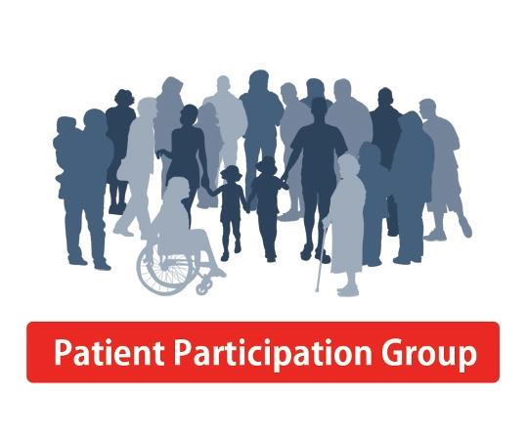

NHS Awareness Campaigns April 2019
Various campaigns are run by the NHS these are designed to educate the public on specific diseases/conditions and help to inform in prevention/treatment as well as support options for those dealing with these illnesses.
If you feel passionate about one of these issues, are someone dealing with one of the mentioned conditions or helping support a friend/family member, you are more than welcome to attend April’s PPG meeting and share information, work to help raise awareness regarding these issues.
Diabetes Prevention Week 1st -7th April 2019

https://www.diabetes.org.uk/preventing-type-2-diabetes/diabetes-prevention-week

Bowel Cancer Awareness Month
1st – 30th April 2019
See article overleaf

https://www.bowelcanceruk.org.uk/support-us/bowel-cancer-awareness-month

World Autism Week 5th April 2019

https://www.autism.org.uk/get-involved/world-autism-awareness-week.aspx

World Parkinson's Awareness Day
11th April 2019

https://www.parkinsons.org.uk/get-involved/parkinsons-awareness-week

Pyjamas for PanCan 16th April 2018

https://pancreaticcanceraction.org/news/pyjamas-for-pancan-is-back-for-2019

Ppg news
Patient | Participation | Group

Joining the PPG allows you to influence the aims and work of the Practice to focus on local needs. This allows you to ensure that your Practice is putting the Patient at the heart of everything it does and allows the Patients to monitor health improvements in primary care, discussing how best to implement them with regards to local community.

There are currently 7 Members in the PPG and together we have looked at and had an active voice in changing things at the Practice.

The next PPG meeting will be Wednesday 17th April 2019 at 6.15_{pm} (on the ground floor) at Attwood Green Health Centre, Bath Row.

Contact: Steve Elliot on 0121 622 4846

GOOD NEWS ABOUT BOWEL SCREENING

Bowel Cancer is one of the most common types of cancer in both men and women. About 1 in 20 will receive a diagnosis during their lifetime and most will be aged over 60. Screening can help detect cancer at an early stage when it is easier to treat. It can also be used to help check for and remove small growths in the bowel called polyps which can develop into cancer over time.

Currently in England, bowel cancer screening is offered every 2 years by means of a home testing kit sent to men and women aged 60 – 74. The good news is that in August 2018 Ministers agreed to National Screening Committee’s recommendation for bowel cancer screening in future to start earlier at aged 50 (as in Scotland). Screening people at a younger age would enable more cancers to be picked up at an earlier stage, where treatment is likely to be more effective and survival chances improved. The NHS and Public Health England are now looking at how this can be achieved.

Marie PPG Member
^{Source Public Health England}

Patient Experience Week 2019
22nd – 26th April
The Beryl Institute

Patient Experience Week 2019 is an annual event to celebrate healthcare staff impacting patient experience every day. Inspired by members of the Institute community, Patient Experience Week provides a focused time for organisations to celebrate accomplishments, re-energise efforts and honour the people who impact patient experience everyday. From nurses and physicians, to support staff and executive professionals, to patients, families and communities served, the Institute hopes to bring together healthcare organisations across the globe to observe Patient Experience Week.

Share your experiences of care with Healthwatch Birmingham by: finding and reviewing services on Feedback Centre email The Beryl Institute with your experiences on:
info@healthwatchbirmingham.co.uk or
call them directly on 0800 652 5278 / 0121 636 0990

Experience of Care Week
23rd – 27th April 2019

Experience of Care week is going global this year as NHS England and NHS Improvement are collaborating with the Beryl Institute in the US, to put a spotlight on the work happening to improve experiences of care for patients, families and staff all over the world. During this week, there will be activities celebrating the amazing things that are happening globally to improve patient/family/carers and staff experiences in healthcare.
The Practice will be closed over the Easter Period on:-

19th April 2019 Good Friday

and

22nd April 2019 Bank Holiday Monday

